КЫРГЫЗСКИЙ ТЕХНИЧЕСКИЙ УНИВЕРСИТЕТ им. И. Раззакова

ФАКУЛЬТЕТ ИНФОРМАЦИОННЫХ ТЕХНОЛОГИЙ

Кафедра «ПРОГРАММНОЕ ОБЕСПЕЧЕНИЕ КОМПЬЮТЕРНЫХ

СИСТЕМ»

Дисциплина

Методы оптимизации

Отчет

по практической работе №1

«Even Search»

Выполнил:

студент группы ПИ-1-16

Абакиров Нурсултан

Проверил:

кандидат технических наук, профессор

Тен Иосиф Григорьевич

Оглавление

Глава 1: Описание проблемы 2

Глава 2: Описание Even Search 3

Глава 3: Стадии проектирования системы для решения одномерной оптимизационной проблемы, использующей Even Search 4

3.1. Блок-схема работы программы, реализующей Even Search 4

3.2: Документирование процесса задания свойств элементов интерфейсной формы системы, выбранной для внедрения и реализующей Even Search. 6

Глава 4: Интерфейс Even Search 9

Глава 5: Стадии конструирования системы для поиска корня нелинейного уравнения f(x)=0, реализующей Even Search: 10

5.1: Код программы на SWIFT, ассоциированный с интерфейсной формой и реализует логику Even Search по поиску корня нелинейного уравнения “ViewController.swift” 10

# Глава 1: Описание проблемы

To solve the one-dimensional optimization problem



using Even Search Method and given an initial approximation x(0) of the searching variable value which obey the inequality x(0) < x*, and given step size H which obeys the inequality H < tol , where x* – is an unknown optimum solution of the problem; H – is a generic parameter of the algorithm; tol – is a required error tolerance.

# Глава 2: Описание Even Search

|  |  |
| --- | --- |
| Mathematical Description of Algorithm of the ESM | Computational Description of Algorithm of the ESM |
| |IF fk >= fk-1 /* Even Search Method to find a ***minimum* */**  | |THEN xk+1 = xk;  | |ELSE xk+1 = xk +H;  |endIF  for all k = 0,1,2,…;  and H <= ε; | **INPUT** {X0; Epsilon; MaxOfIterations; f(X);}  **Body of algorithm**  H: = Epsilon;  YF0: = f (X0);  X1: = X0 + H;  YF1: = f(X1);  K:=0;  |WHILE K < MaxOfIterations DO  | K: = K+1;  | |IF YF1 >= YF0 /* Even Search Method to find a ***minimum* */**  | | |THEN DO X1: = X0; YF1: = YF0; END;  | | |ELSE |DO  | | | X0: = X1;  | | | YF0: = YF1;  | | | X1: = X0 + H;  | | | YF1: = f(X1);  | | |END;  | |endIF;  |endWHILE;  **OUTPUT**  PRINT ‘The optimum solution x* equal’ X1  PRINT ‘The optimum solution was found with the desired tolerance’ Epsilon  PRINT ‘The minimum of objective function f(x*) is’ YF1  PRINT ‘The accuracy is ±‘ Epsilon |
| x0 – Initial approximation;  H –Step-size of search;  ε – Tolerance;  fk = f(xk) – objective function at point xk. | X0 – Initial approximation;  H –Step-size of search;  Epsilon – Tolerance;  MaxOfIterations – Limiting number of iterations. |

# Глава 3: Стадии проектирования системы для решения одномерной оптимизационной проблемы, использующей Even Search

# 3.1. Блок-схема работы программы, реализующей Even Search

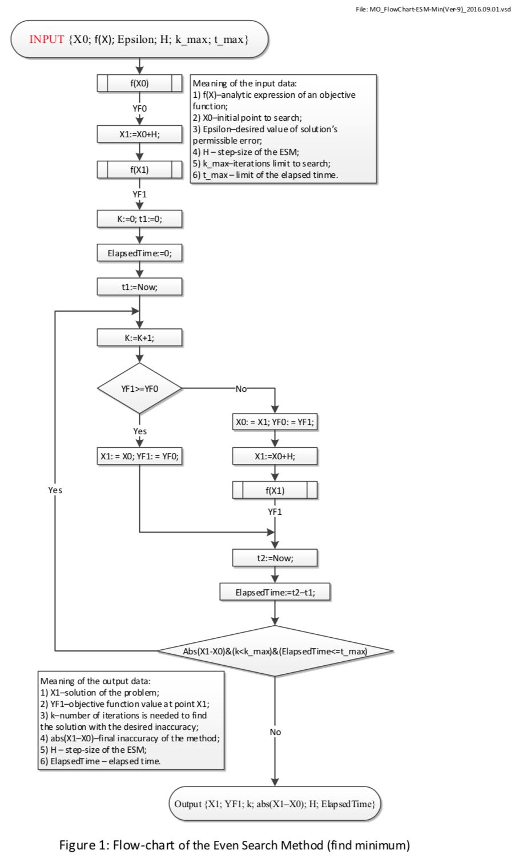

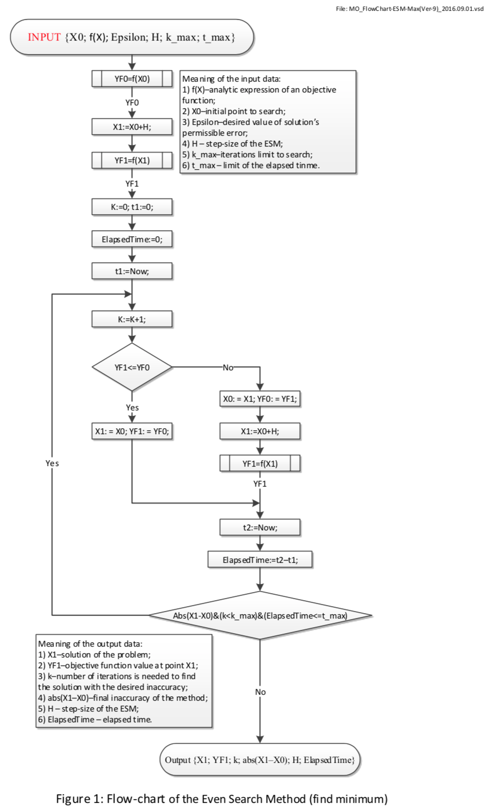

## 3.2: Документирование процесса задания свойств элементов интерфейсной формы системы, выбранной для внедрения и реализующей Even Search.

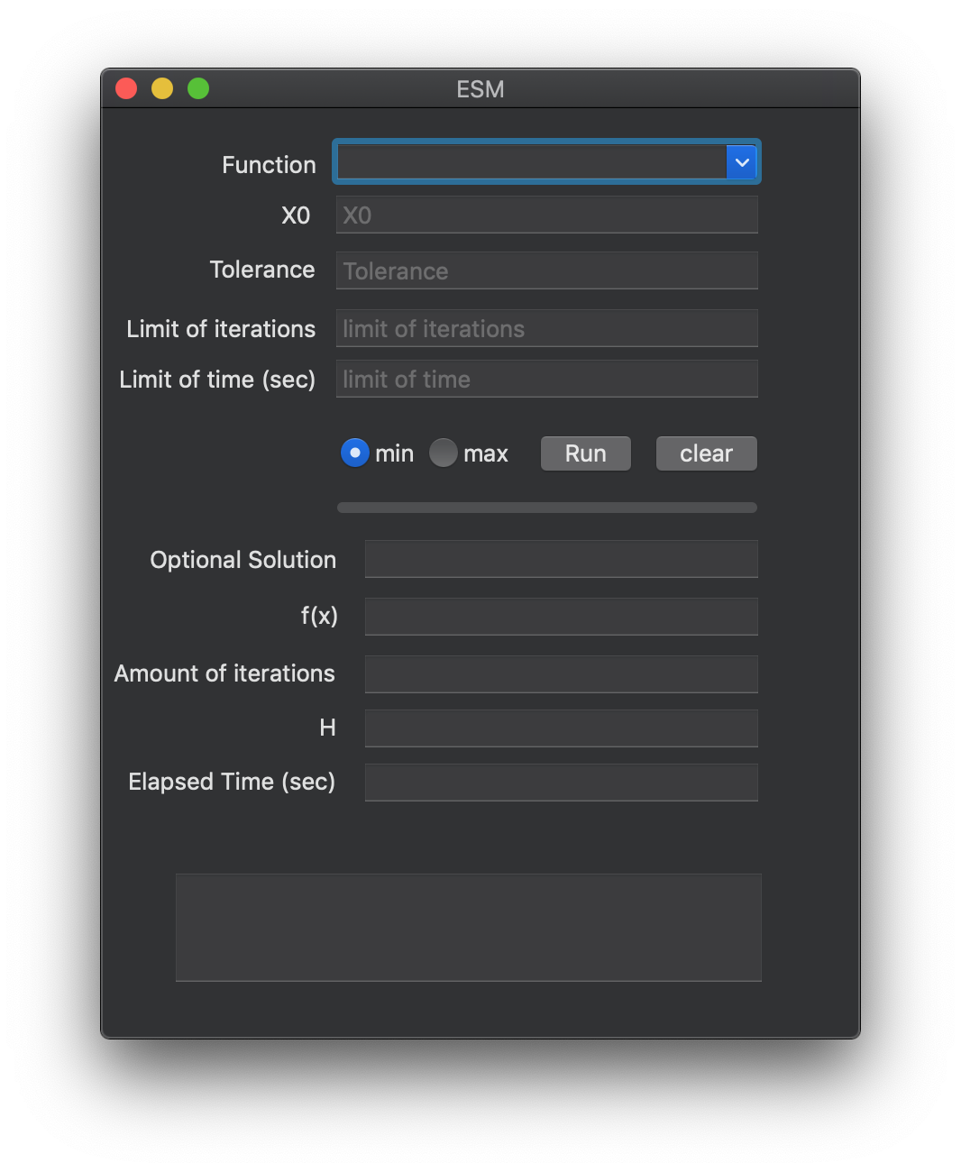

Figure 3: Program interface

Table 1: Settings for control properties of the software system implementing Even Search

|  |  |  |  |
| --- | --- | --- | --- |
| **Number of control** | **Control** | **Property** | **Setting** |
| 1 | Label1 | Appearance (Text) | Function |
| Design (Name) | Label1 |
| 2 | Combobox1 | Appearance (Text) | Empty |
| Design (Name) | functionInput |
| Items | pow(x, 2)-4*sin(x)  pow((x-2),2)-log(x)  1600*(1-exp(-x/5))-160*x  x*exp(-x)  pow(4*x, 3)-2*x-6  1500*pow(x, 3)-0.001*exp(2*x)  0.01*pow(exp(x),2) |
| 3 | Label2 | Appearance (Text) | X0 |
| Design (Name) | Label3 |
| 4 | Textbox1 | Appearance (Text) | X0 |
| Design (Name) | x0Input |
| 5 | Label3 | Appearance (Text) | Tolerance |
| Design (Name) | Label |
| 6 | Textbox2 | Appearance (Text) | Tolerance |
| Design (Name) | toleranceInput |
| 7 | RadioButton1 | Appearance (Text) | min |
| Design (Name) | minInput |
| 8 | RadioButton2 | Appearance (Text) | max |
| Design (Name) | maxInput |
| 9 | Label5 | Appearance (Text) | Limit of Iterations |
| Design (Name) | Label4 |
| 10 | Textbox4 | Appearance (Text) | Limit of iteration |
| Design (Name) | kMaxInput |
| 11 | Label6 | Appearance (Text) | Limit of Time |
| Design (Name) | Label12 |
| 12 | Textbox5 | Appearance (Text) | Limit of time |
| Design (Name) | tMaxInput |
| 13 | Button1 | Appearance (Text) | Run |
| Design (Name) | Button1 |
| 14 | Button1 | Appearance (Text) | Clear |
| Design (Name) | clearBntClicked |
| 15 | ProgressBar1 | Behavior (Visible) | true |
| Design (Name) | progressBar |
| 16 | Label7 | Appearance (Text) | Optimal Solution |
| Design (Name) | Label5 |
| 17 | Textbox6 | Design (Name) | x1Output |
| Behavior | selectable |
| Appearance (Text) | Empty |
| 18 | Label8 | Appearance (Text) | F(x) |
| Design (Name) | Label7 |
| 19 | Textbox7 | Design (Name) | yf1Output |
| Behavior | selectable |
| Appearance (Text) | Empty |
| 20 | Label9 | Appearance (Text) | Amount of iterations |
| Design (Name) | Label7 |
| 21 | Textbox8 | Design (Name) | kOutput |
| Behavior | selectable |
| Appearance (Text) | Empty |
| 22 | Label11 | Appearance (Text) | Elapsed time (sec) |
| Design (Name) | Label9 |
| 23 | Textbox10 | Design (Name) | elapsedTimeOutput |
| Behavior | selectable |
| Appearance (Text) | Empty |
| 24 | Label12 | Appearance (Text) | “” |
| Design (Name) | message |

# Глава 4: Интерфейс Even Search



# Глава 5: Стадии конструирования системы для поиска корня нелинейного уравнения f(x)=0, реализующей Even Search:

## 5.1: Код программы на SWIFT, ассоциированный с интерфейсной формой и реализует логику Even Search по поиску корня нелинейного уравнения “ViewController.swift”

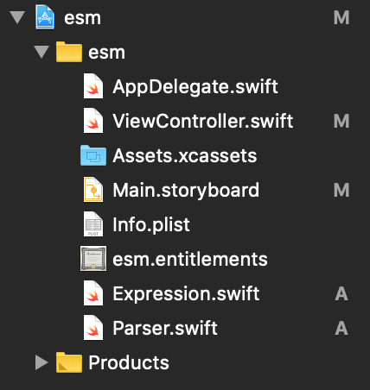

//

// ViewController.swift

// esm

//

// Created by user on 12/8/18.

// Copyright © 2018 user. All rights reserved.

//

import Cocoa

class ViewController: NSViewController {

@IBOutlet weak var functionInput: NSTextField!

@IBOutlet weak var x0Input: NSTextField!

// @IBOutlet weak var hInput: NSTextField!

@IBOutlet weak var toleranceInput: NSTextField!

@IBOutlet weak var kMaxInput: NSTextField!

@IBOutlet weak var tMaxInput: NSTextField!

@IBOutlet weak var minInput: NSButton!

@IBOutlet weak var maxInput: NSButton!

@IBOutlet weak var functionsInput: NSComboBoxCell!

@IBOutlet weak var x1Output: NSTextField!

@IBOutlet weak var yf1Output: NSTextField!

@IBOutlet weak var kOutput: NSTextField!

@IBOutlet weak var hOutput: NSTextField!

@IBOutlet weak var elapsedTimeOutput: NSTextField!

@IBOutlet weak var progressBar: NSProgressIndicator!

@IBOutlet weak var messageOutput: NSTextField!

override func viewDidLoad() {

super.viewDidLoad()

// Do any additional setup after loading the view.

}

override var representedObject: Any? {

didSet {

// Update the view, if already loaded.

}

}

@IBAction func maxClicked(_ sender: Any) {

minInput.state = NSControl.StateValue(rawValue: 0)

}

@IBAction func minClicked(_ sender: Any) {

maxInput.state = NSControl.StateValue(rawValue: 0)

}

@IBAction func runBtnClicked(_ sender: Any) {

self.clear()

if !self.isValid() {

return

}

var x0 = x0Input.doubleValue

let f = Parser(expression: functionsInput.stringValue)

let tol: Double = toleranceInput.doubleValue

let h: Double = tol

var kMax: Int = kMaxInput.integerValue

let tMax: Double = tMaxInput.doubleValue

var isMin: Bool

var yf0: Double = f.run(x: x0)

var x1: Double = x0 + h

var yf1: Double = f.run(x: x1)

var k: Int = 0

if minInput.state == NSControl.StateValue(rawValue: 1) {

isMin = true

} else {

isMin = false

}

let startTime = Date()

var endTime = NSDate()

var found: Bool = false

var isTimeReached = false

progressBar.doubleValue = 0.0

repeat {

k += 1

progressBar.doubleValue = Double(k * 100 / kMax)

if isMin{

if yf1 >= yf0 {

x1 = x0

yf1 = yf0

found = true

messageOutput.stringValue = "Found minimum of function with a given \ntolerance \(tol)"

} else {

x0 = x1

yf0 = yf1

x1 = x0 + h

yf1 = f.run(x: x1)

}

} else {

if yf1 <= yf0 {

x1 = x0

yf1 = yf0

found = true

messageOutput.stringValue = "Found maximum of function with a given \ntolerance \(tol)"

} else {

x0 = x1

yf0 = yf1

x1 = x0 + h

yf1 = f.run(x: x1)

}

}

endTime = NSDate()

if k == kMax {

if self.dialogOKCancel(question: "Continue Search?", text: "Solution was not found in given limit of iterations, add \(kMax) more iterations") {

kMax += kMax

kMaxInput.stringValue = String(kMax)

} else {

messageOutput.stringValue = "Not possible to find solution for given \namount of iterations \(kMax)"

}

}

if endTime.timeIntervalSince(startTime) >= tMax {

isTimeReached = true

messageOutput.stringValue = "Not possible to find solution for given \ntime limit \(tMax)"

}

} while k < kMax && !isTimeReached && !found

if k == 1 && found {

messageOutput.stringValue = """

Can't find an extremum or initial point is placed in

the right-of-solution X*. Note: The right-of-side range

of solution x* is a forbidden area. Try to revice

initial point to check validaty of the value x0

"""

self.alertModal(messageText: "Try X0 be lefter and closer to X*", informativeText: "Found not best fit X*")

}

progressBar.doubleValue = 100

x1Output.doubleValue = x1

yf1Output.doubleValue = yf1

kOutput.stringValue = String(k)

hOutput.doubleValue = h

elapsedTimeOutput.doubleValue = endTime.timeIntervalSince(startTime)

}

@IBAction func clearBntClicked(_ sender: Any) {

self.clear()

}

func clear() {

x1Output.stringValue = ""

yf1Output.stringValue = ""

kOutput.stringValue = ""

hOutput.stringValue = ""

elapsedTimeOutput.stringValue = ""

messageOutput.stringValue = ""

progressBar.doubleValue = 0

}

func setInvalidInput() {

self.alertModal(messageText: "invalid input", informativeText: "")

messageOutput.stringValue = "invalid input"

}

func isValid() -> Bool {

for raw in [functionsInput.stringValue] {

let f = Parser(expression: raw)

do {

_ = try f.check_run(x: 1)

} catch {

self.setInvalidInput()

return false

}

}

for el in [x0Input, toleranceInput, kMaxInput, tMaxInput] {

if Double(el!.stringValue) == nil {

self.setInvalidInput()

return false

}

}

return true

}

func alertModal(messageText: String, informativeText: String) {

let alert = NSAlert()

alert.messageText = messageText

alert.informativeText = informativeText

alert.alertStyle = .warning

alert.addButton(withTitle: NSLocalizedString("OK", comment: "OK"))

alert.runModal()

}

func dialogOKCancel(question: String, text: String) -> Bool {

let alert = NSAlert()

alert.messageText = question

alert.informativeText = text

alert.alertStyle = .warning

alert.addButton(withTitle: "OK")

alert.addButton(withTitle: "Cancel")

return alert.runModal() == .alertFirstButtonReturn

}

}

**Подключение библиотечной программы “ Expression ” к программному проекту для выполнения функции парсинга**

Шаг №1: Скачать с сайта https://github.com/nicklockwood/Expression/tree/master/Sources

файл парсера [Expression.swift](https://github.com/nicklockwood/Expression/blob/master/Sources/Expression.swift):

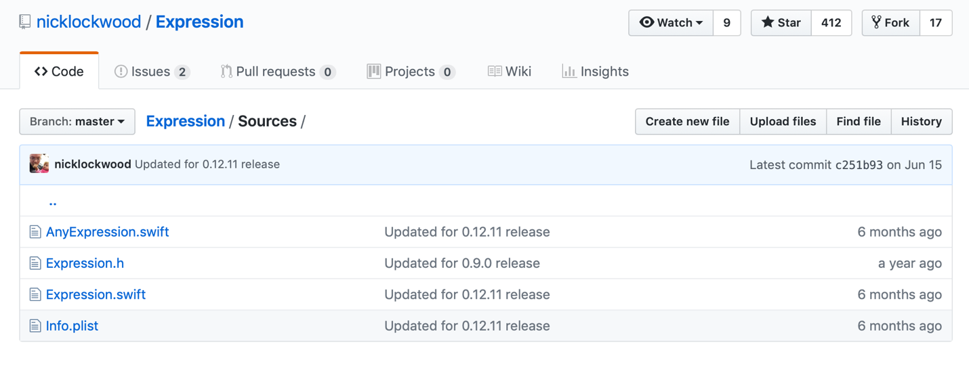

Шаг №2: Вставить скаченный файл в папку проекта:

Шаг №3: Так как парсер не предоставляет полный спектр математических функций, дописываем файл Parser.swift

**import** Foundation

**class** Parser {

**private** **var** expression: Expression

**private** **var** x: Double

**init**(expression: String) {

**self**.x = 0

**self**.expression = Expression("1 + 1")

**self**.expression = Expression(expression, symbols: [

.variable("x"): { **_** **in** **self**.x},

.function("exp", arity: 1): {args **in** exp(args[0])},

.function("log", arity: 1): {args **in** log(args[0])},

])

}

**public** **func** run(x: Double) -> Double {

**self**.x = x

**do** {

**return** **try** **self**.expression.evaluate()

} **catch** {

fatalError()

}

}

}

# Раздел №6 Тестирование

1. Тест №1 функция: x^2-4*sin(x)

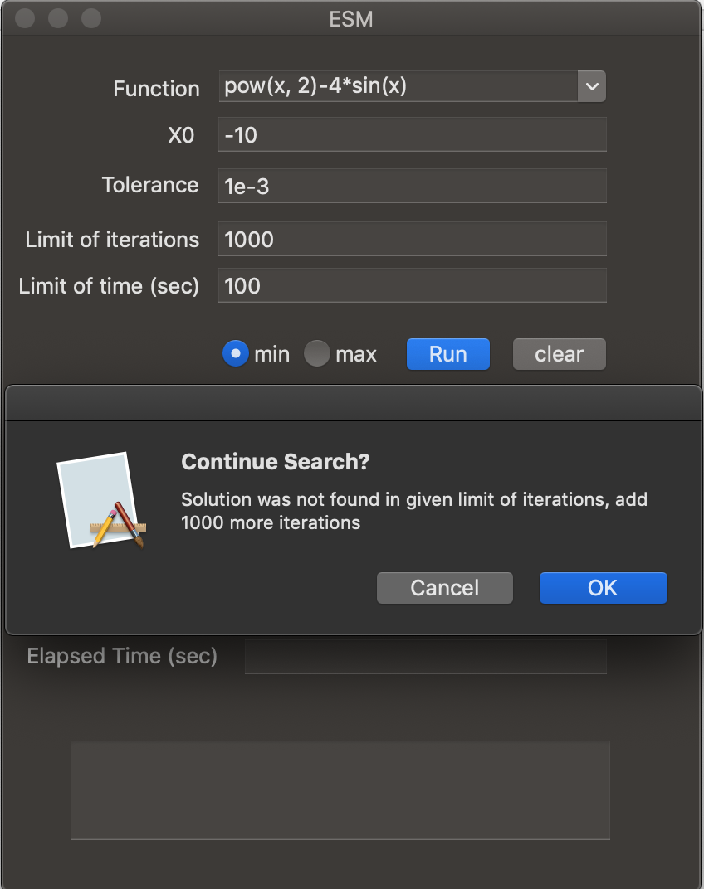

2.Тест№2. Проверка на вывод ошибки о недостаточном количестве времени



3.Тест№3. Проверка вывода сообщения о том, что входные данные некорректны



Тест №4

pow(x, 2)-4*sin(x)

